SCREEN SPECIFICATION FOR PLACE RUSH ORDER SCREEN

1. Figma link: https://www.figma.com/file/ism6aqDK1ssfG5Xxeijam9/AIMS-Project?type=design&node-id=0%3A1&mode=design&t=XkRQqgvD4VGkslMx-1
2. Overview image
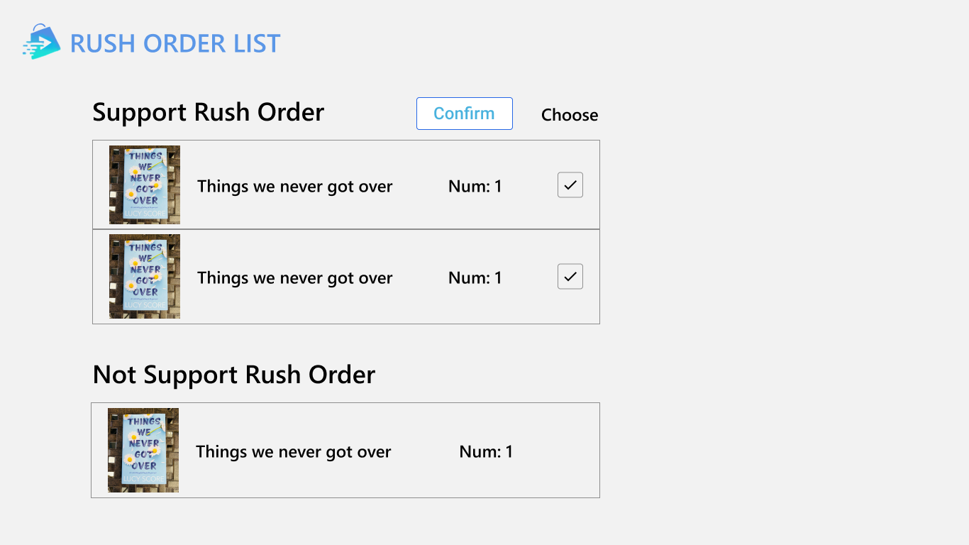
3. Screen specifications for place rush order screen
AIMS Software |  | Date of creation | Approved by | Reviewed by | Person in charge
Screen specification | Rush order screen | 6/4/2024 |  |  | Dinh Viet Quang
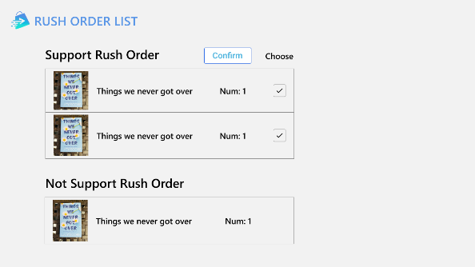 |  | Control | Operation | Function
 |  | Area for displaying rush order supported items | Initial | Display items that rush order supports
 |  | Area for displaying rush order unsupported items | Initial | Display items that rush order doesn’t support
 |  | Area for displaying item information | Initial | Display image, title, amount of that item
 |  | Item’s check box | Click | Select items that user wants to buy
 |  | Confirm button | Click | Confirm the rush order

